Pakistan J. Zool., vol. 43(3), pp. 473-476, 2011.

Redescription of Dysdercus melanoderes Karsch (Hemiptera: Pyrrhocoridae) With Reference to its Unknown Male Genitalia and its Phylogenetic Relationships

Imtiaz Ahmad¹ and Syed Salahuddin Qadri²
¹Dr. Afzal Hussain Qadri Biological Research Center, University of Karachi, Karachi-75270.
²Department of Zoology, Jamia Millia Government Degree College, Malir, Karachi, Pakistan

Abstract.- Dysdercus melanoderes Karsch is re-described in detail with special reference to its unknown meta thoracic scent auricle and male genitalia including inflated aedeagus. In this light it is compared with its closest allies and its phylogenetic relationship is also briefly discussed.

Keywords: Dysdercus melanoderes, genitalia, Hemiptera, Pyrrhocoridae, phylogeny.

INTRODUCTION

The species of Dysdercus Guérin-Méneville are the pest of Malvacian plant, mainly cotton. It is the largest and most important genus of the family Pyrrhocoridae which according to Hussey’s (1929) Catalogue comprises three subgenera and 77 new and old-world species. Freeman (1947) was probably the first to give descriptions and some time illustrations of parameres, spermatheca and vertical processes in the pygophore. Freeman (op. cit.) categorised the genus Dysdercus in four groups and placed Dysdercus melanoderes Karsch in group I without vertical processes in the pygophore with species (excluding D. festivus Gerstaecker) distributed in the Ethopian region. He further divided group I into two groups i.e. I a on the basis of apex of pygophore rounded, spermatheca with no separate accessory gland, having proximal portion comparatively short and wide probably incorporating glandular cells. Freeman (op.cit.) separated group I b on the basis of apex of pygophore conical; spermathecal duct long and coiled with separate accessory gland.
Freeman’s above groups of Dysdercus were established as sub-genera viz., Dysdercus sensu stricto (with type species D. superstitiosus (F.), and
_________________________
* Part of the Ph. D. thesis of first author.
** Corresponding author: iahmad3141@yahoo.com
0030-9923/2011/0003-0473 $ 8.00/0
Copyright 2011 Zoological Society of Pakistan.
extending its distribution to new world), Neodysdercus Stehlik, Paradysdercus Stehlik and Megadysdercus Breddin by Stehlik (1965a and b). Dysdercus melanoderes Karsch is here redescribed in detail with special reference to its unknown metathoracic scent auricle and male genitalia including inflated aedeagus and in this light its relationship within its subgenus Dysdercus s. str. is also briefly discussed.

MATERIALS AND METHODS

The specimens of D. melanoderes were gifted to the second author by the courtesy of Prof. Dr. S. N. H. Naqvi. The measurements were taken and the illustrations were made following the technique of Ahmad et. al. (2003). For the study of male genitalia particularly for the inflation of the aedeagus the techniques of Ahmad (1986) and Ahmad and McPherson (1990, 1998) were generally followed. For the inflation of aedeagus the pinned dry specimen after removing the label, was softened plunging into boiling water in a beaker, for 4-5 minutes. The specimen was then slipped of the pin. The genital capsule (pygophore) was removed from the relaxed specimen under a binocular microscope, using very fine watch maker forceps (5 or finer). The genital capsule was placed in 10% KOH and was warmed at 40ºC for 5-10 minutes in a cavity block. The capsule was removed in tap water (room temperature) in a depression dish and was washed thoroughly. The above mentioned fine forceps were used to hold the basal plate (attaching aedeagus to capsule) and then with the help of forceps the opening of phallotheca was widened very carefully and conjunctiva was pulled out gently. This was done very carefully because the distal tip of vesica and conjunctival appendages are very delicate and break off quickly. The examination of various structures and their diagrams were made placing these on cotton threads immersed under glycerin with the help of eyepiece graticule. The male genitalial parts were preserved in a micro vial with a drop of glycerin, pinned with the specimen. All the measurements are given in millimeters and all illustrations are to the given scales.

RESULTS

Dysdercus melanoderes Karsch
(Figs. 1 – 2)

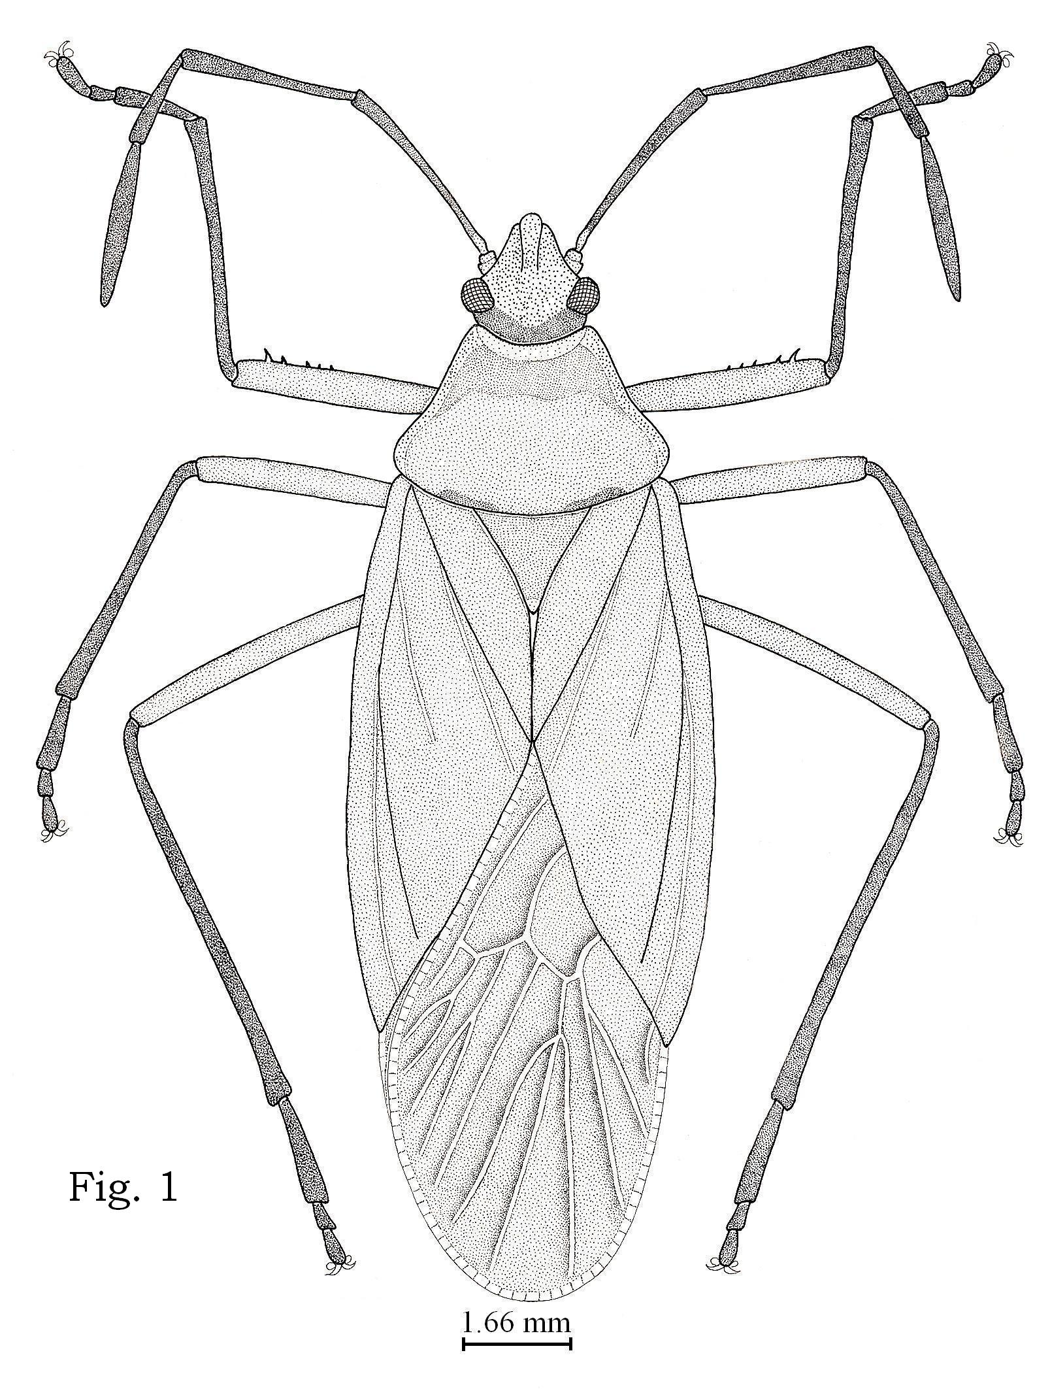

Fig. 1. Dysdercus. melanoderes Karsch.

Dysdercus melanoderes Karsch 1892 : 133; Karsch 1894 : 106; Haglund 1895: 467; Distant 1902: 542; Schouteden 1912: 303, 305; Hussey 1929 : 94; Blöte 1931: 128; Schmidt 1932: 277; Freeman 1947 : 391.
Dysdercus nigrofaciatus var. (b) Stål 1866: 15.

Colouration
Body ochraceous except posterior portion of head with brownish shade; antennae, tibiae and tarsi dark brown; membrane dark hyaline, outer margin opaque.

Head
Anteocular distance equal to remainder of head, length of head subequal to ¾x of its width, length of head 1.6, width, 2.2; antennae with second segment more than 1½x the length of third, length of segments I 3.5, II 2.6, III 1.5, IV 3.6, antennal formula 3<2<1<4; labium reaching to third abdominal venter, basal segment longest, much longer than length of third, length of segments I 2.1, II 1.8 III 1.5, IV 1.4, labial formula 4 < 3 < 2 < 1; length anteocular distance 0.8; length remainder of head 0.8; interocular distance 1.0.

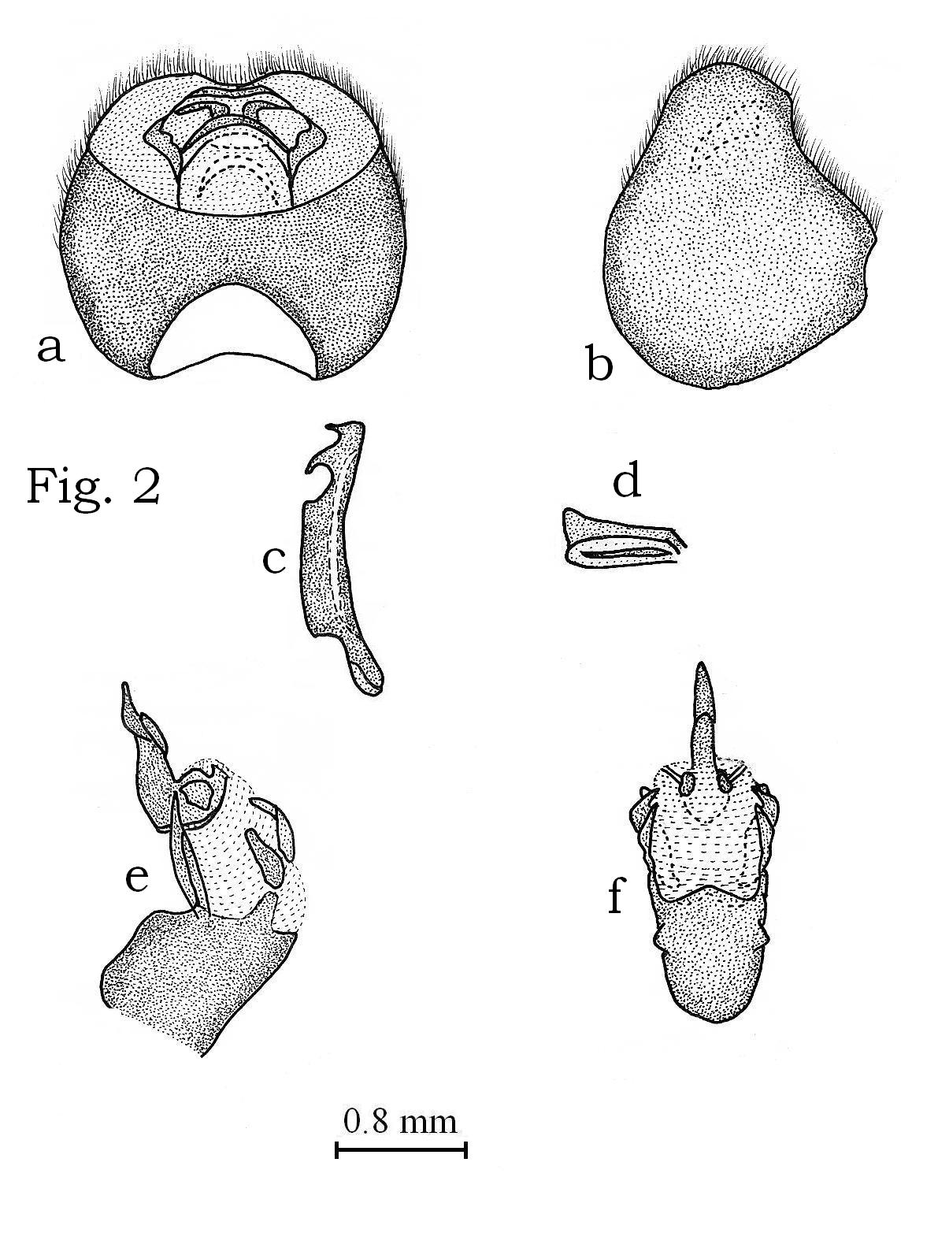

Fig. 2. Dysdercus. melanoderes Karsch, a, pygophore, dorsal view; b, pygophore, lateral view; c, paramere, inner view; d, metathoracic scent gland ostiolar peritreme, ventral view; e, inflated aedeagus, lateral view; f, inflated aedeagus, ventral view.

Thorax and abdomen
Width of the pronotum about 1½x of its length, anterior angles of pronotum subrounded, posterior angle rounded, lateral margins sinuate, length of pronotum 2.8, width 4.2; scutellum as long as broad, length of scutellum 1.6, width 1.6; metathoracic scent gland ostiolar peritereme (Fig. 2d) lobe-like, short evaporatoria very narrow, placed only anterior to auricle; distance base scutellum apex clavus 3.4; apex clavus-apex corium 4.6; apex corium-apex abdomen including membrane 3.9; apex scutellum-apex abdomen including membrane 10.4; Total length male 17.6.

Male genitalia
Pygophore (Figs. 2a and b) somewhat rounded; broadest at middle; dorsoposterior margin concave; ventroposterior margin convex at sides, medially concave with two teeth or tubercle; capsular lamella small, medially concave; paramere (Fig. 2c) with shaft long, outer margin concave, inner margin truncate; neck short; head rounded; with two spurs, apical spur straight, small, proximal spur hook like, long; inflated aedeagus (Figs. 2e and f) without pair of ventro-larteral membranous conjunctival appendages and pair of slender curved third dorsal conjunctival appendages; pair of curved second conjunctival appendages, pair of leaf shaped first conjunctival appendages. Female specimen not available presently but its spermatheca was briefly described by Freeman (1947).

Material examined
1 male, Nigeria 1981, leg. S. N. H. Naqvi, lodged at Natural History Museum, Department of Zoology, University of Karachi (NHUK). 1 female, Nigeria: olfat 1903 also seen by the first author at BMNH.

Comparative note
This species is most closely related to flavidus Signoret, nigrofasciatus Stål, ortus Distant and superstitiosus (F.) in having pygophore round with sharp edges, medially concave with two tubercles at sides, pleuron of abdominal segment clearly red and white patterned and paramere stout, dorsal side flat with apically setose stem but it appears isolated in its group and could easily be separated from other species of its group in having corial membrane pale with anterior femora sharply spinose along their entire length and parameral distal spur not continuous with proximal spur.
DISCUSSION

This species appears to belong to subgenus Dysdercus s. str. on the basis of synapomorphic characters i.e., pygophore rounded without vertical process, paramere stout, parameral blade with dorsal spur like projections, spermatheca without separate accessory gland and spermathecal duct with proximal portion swollen with fused accessory gland. This is indeed Ia of Freeman (1947) called by him as superstitiosus group and treated by Stehlik (1965a) as Dysdercus s. str.. This species appears closely related to cardinalis Gerstaecker, fasciatus Signoret, flavidus Signoret, nigrofasciatus Stål, ortus Distant, and superstitiosus (F.) on the basis of second gonocoxae flat, close together and parameral stem apically setose (Fig. 3). The apomorphy of paramere stout, dorsal side flat with apically setose stem and pygophores with sharp edge, medially concave with two tubercles at sides, species with clearly red and white pattern closely relate it with, flavidus, nigrofasciatus, ortus, and superstitiosus. In this complex of species melanoderes appears to be entirely isolated playing outgroup relationships and having apomorphy of corial membrane pale with anterior femoral spines along their length and paramere with dorsal side flat and distal spur not continuous with proximal spur.

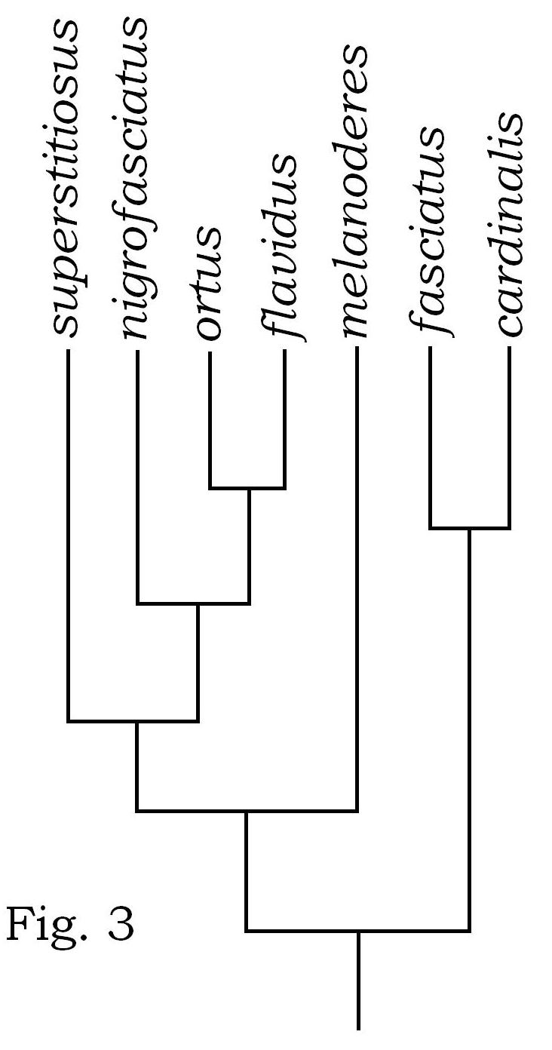

Fig. 3. Cladogram showing phylogenetic relationship of melanoderes with related species.
REFERENCES

AHMAD, I., 1986. A fool proof Technique for inflation of male genitalia in Hemiptera (Insecta). Pak. J. Ent. Karachi, 1: 111-112.
AHMAD, I. AND MCPHERSON, J. E., 1990. Male genitalia of the type species of Coriomelaena White, Cydnoides Malloch and Galgupha Amyot and Serville (Hemiptera : Cydnidae : Coriomelaeninae) and their bearing on classification. Ann. ent. Soc. Am., 83: 162-170.
AHMAD, I. AND MCPHERSON, J.E., 1998. Additional information on male and female genitalia of Parabrochymena Lariviere and Brochymena Amyot and Serville (Hemiptera: Pentatomidae). Ann. ent. Soc. Am., 91: 800-807.
AHMAD, I., QADRI, S. S. AND KAMALUDDIN, S., 2003. Redescription and new record from Japan of Dysdercus mesiostigma Distant (Hemiptera : Pyrrhocoridae). Pakistan J. Zool., 35: 177-180.
BLÖTE, H.C., 1931. Catalogue of the Pyrrhocoridae in’ S Rijks Museum van Natuurlijke Historie. Zool. Meded. (Leiden), 14: 97-136.
DISTANT, W. L., 1902. Description of new species of South Africa Rhynchota. Trans. R ent. Soc. Lond., 902: 542-544.
FREEMAN, P., 1947. A revision of the genus Dysdercus Boisduval (Hemiptera: Pyrrhocoridae), excluding the American species. Trans. R. ent. Soc. Lond., 98: 373-424.
HAGLUND, C.J.E., 1895. Beiträge zur Kenntniss der Insektenfauna von Kamerun. 4, Verzeicniss der von Yngve Sjöstedt im nordwestliche Kamerungebiete eingesammelten Hemipteren. Öfvers. Vetensk Akad. Förh. Stockh., 1895: 445-479.
HUSSEY, R.F., 1929. Pyrrhocoridae: General catalogue of the Hemiptera. Part III, Smith Coll., North Hampton, Mass, USA, pp. 144.
KARSCH, F., 1892. Kurze Charakteristik neuer Wanzen aus Kamerun. gesammelt durch Herrn Dr. Paul Preuss. Entomol. Nachr., 18: 129-144.
KARSCH, F., 1894. Verzeichniss der von Herrn Dr. Paul Preuss in Kamerun gesammelten Schnabelkerfe nebst Beschreibung der neun Arten. Stettin. ent. Zig., 55: 99-116.
SCHMIDT, E., 1932. Zur Kenntnis der Familie Pyrrhocoridae Fieber (Hemiptera,Heteroptera). Teil II. Subfamilie Pyrrhocorinae. Wien. Ent. Zeit., 49: 236-281.
SCHOUTEDEN, H., 1912. Les Hemipteres parasites des Cotonniers en Afrique. Rev. Zool. Afr., I, Fasc. B.: 297-321.
STÅL, C., 1866. Hemiptera Africana. Holmiae: Norstedtiana, Vol. 3, pp. 200.
STEHLIK, J.L., 1965a. Mission zoologique de I’ I. R. S. A. C. en Afrique orientale (P. Basilewasky-N. Leleup. 1957) Pyrrhocoridae (Het.). Acta Mus. Mor. Sci.e nah. vedy Prirodni, 50: 211-252.
STEHLIK, J.L., 1965b. Pyrrhocoridae and Largidae collected by E. S. Brown on Solomon Island (Heteroptera). Acta Mus. Mor. Sci.e nah. vedy Prirodni, 50: 253-292.

(Received 28 April 2010, revised 25 September 2010)

